Supplementary Specifications
Requirements

Date: | 15/10/2012
Version: | 0.2
Status: | Ready for review and baseline
Author: | Vy Nguyen
Reviewed by:
Approved by:
Revision History
Date | Version | Description | Author
10/09/2012 | 0.1 | Initial draft | Vy Nguyen
15/10/2012 | 0.2 | Baseline document | Vy Nguyen

Table of Contents
1 Introduction 4
1.1 Purpose 4
1.2 Preferences 4
2 Feature List 4
2.1 Functional requirement 4
2.2 Non-functional requirement 5
3 Workflow 5
4 Entity Diagram 7
5 Screen Flow 7
6 Functional Requirement Details 7
6.1 FRONT END 7
6.1.1 Homepage 7
6.1.2 Menu Category – Menu List – Menu Item Detail 9
6.1.3 My Order 13
6.1.4 Customer Feedback 14
6.1.5 Table Detail 16
6.1.6 Settings 17
6.2 BACK END 19
6.2.1 Login 19
6.2.2 Category Management 20
6.2.3 Dish Management 22
6.2.4 Today Special Management 26
6.2.5 Order Management 28
6.2.6 Table Management 29
6.2.7 Customer Feedback Management 32
6.2.8 User Management 33
6.2.9 Reports 34

Introduction

Purpose
The purpose of this document is to give a detail of requirements of iMenu application built on iPad device.
iMenu is an electronic menu in which all dishes/drinks are displayed on a handheld device with an attractive, intuitive, user friendly way to customers to explore/order various dishes served by a restaurant.

Preferences
- iMenu Overview written by Lam Dac Ngo (iMenu_Overview.pptx)

Feature List

Functional requirement
Front end
- Homepage
- Category list
- Menu list
- Menu detail
- Order detail
- Order list
- Customer feedback menu item
- Table detail
- Synchronization
- Log in/out
- Select table

Back end
- Login
- Menu category management
- Menu item (dish) management
- Today special management
- Order management
- Table management
- Customer feedback management
- User management
- Report management

Non-functional requirement
- Front end features are built as a native application on iPad.
- Back end features are built as a web-based application.

Workflow
Order Process workflow
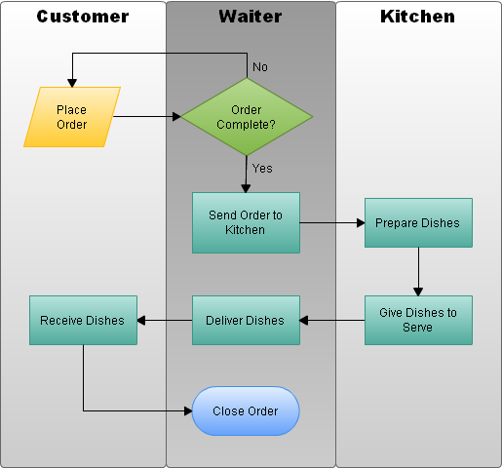
Note: The main users are waiters who will place orders, change status of orders and deliver dishes to customers to finish an order process.

Entity Diagram
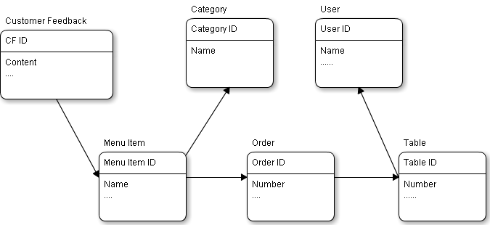

Screen Flow
Front End
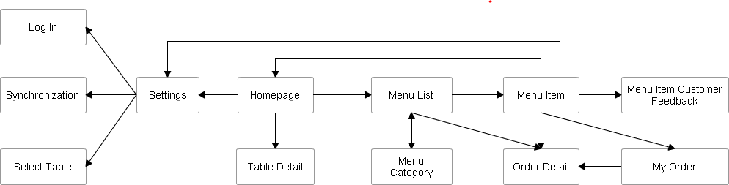

Functional Requirement Details

FRONT END

Homepage

Screen
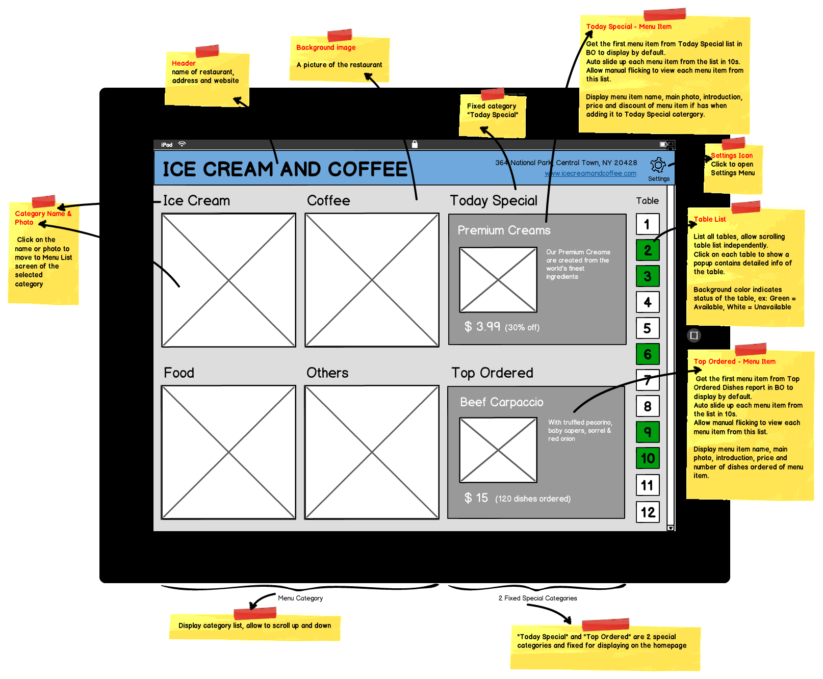
Refer to “Mockups/Images/Front-end/Home page.png”

Flow
- User access iMenu application from iPad to see Homepage screen.
- From Homepage, users are able to access to Menu List screen via each category (photo or name), view detailed information of a table, or access Settings menu to customize.

Business Rule
- Category List
  - List all categories from database, there is scrolling up and down to view all them.
- Special Categories:
  - There are 2 special categories which are fixed: “Today Special” (all dishes are offered for the current day with promotions or special cooked) and “Top Ordered” (list of dishes that are got from each category in which that dish has been ordered the most).
  - Today Special:
    - Get the first menu item from Today Special list in BO to display by default.
    - Auto slide up each menu item from the list in 10s.
    - Allow manual flicking to view each menu item from this list.
    - Display menu item name, main photo, introduction, price and discount of menu item if has.
  - Top Ordered:
    - Get the first menu item from Top Ordered Dishes report in BO to display by default.
    - Auto slide up each menu item from the list in 10s.
    - Allow manual flicking to view each menu item from this list.
    - Display menu item name, main photo, introduction, price and number of dishes ordered of menu item.
- Table List
  - List all tables from database with a scrolling to move up and down through the table list independently with other sections.
  - Click on each table to show a popup contains detailed info of the table.
  - Background color indicates status of the table, ex: Green = Available, White = Unavailable, Yellow = Current Table.
- Settings
  - There are 3 functionalities in Settings menu: Sign In, Synchronization and Select Table.
  - Refer to Settings section below for more details.

Menu Category – Menu List – Menu Item Detail

Screen
Menu Category
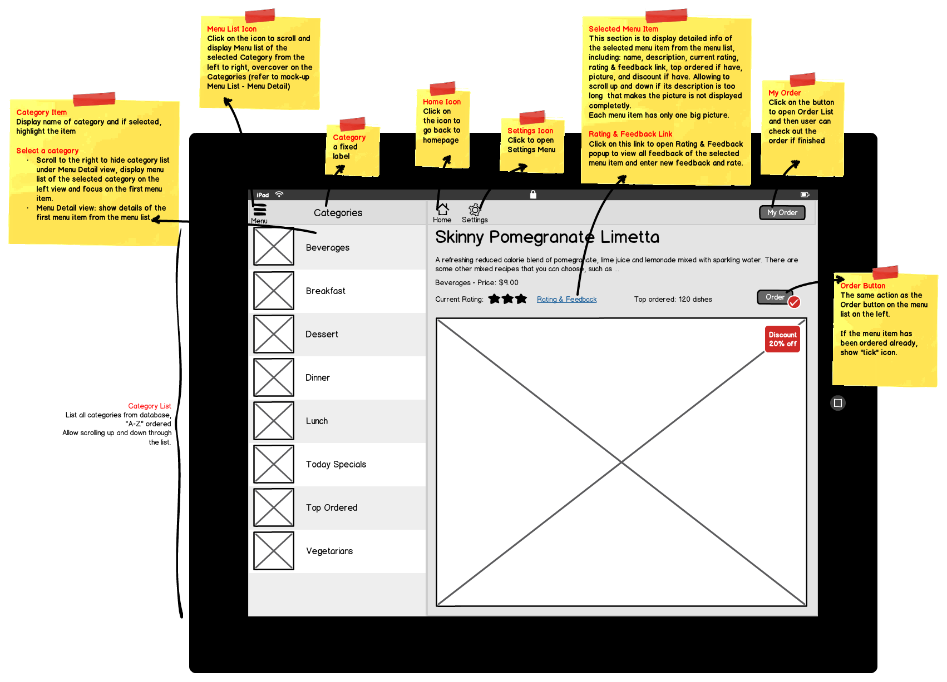
Refer to “Mockups/Images/Front-end/Category List - Menu Detail.png”

Menu List
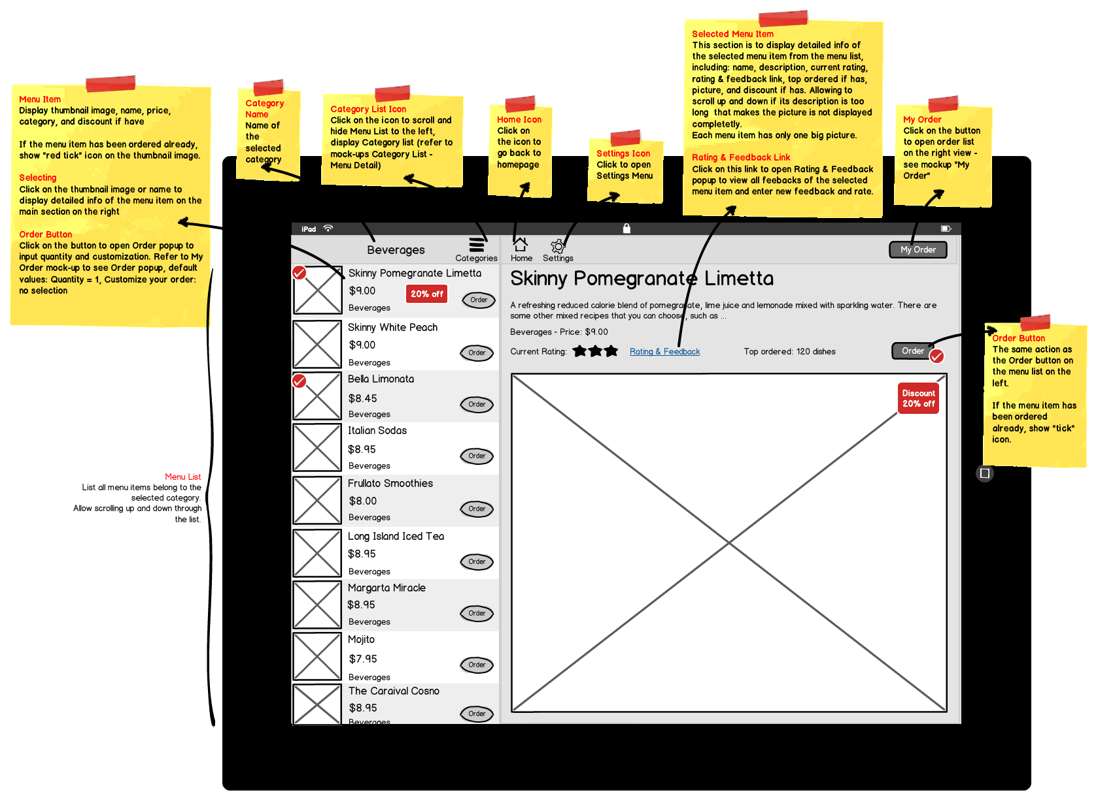
Refer to “Mockups/Images/Front-end/Menu List - Menu Detail.png”

Flow
- User access Menu List from Home page or from Menu icon in navigation on the top.
- From Categories icon and Menu icon in the navigation, users can switch between Menu List and Category List on the left view of the screen.
- Details of the selected menu item are shown on the right view whenever users select an item.
- User can use one of two “Order” buttons on the Menu List of each menu item or in the details view of the selected menu item to make an order. Order Details popover will be displayed on top to input order details information – refer to My Order section below for details of fields – and close the popover after done. The order will be added to the list of orders of the current table at the moment.
- Using My Order button to view the order list of the current table which are not confirmed – refer to My Order section below.

Business Rule
- Menu List Icon: to scroll and display Menu list of the selected Category from the left to right, over cover on the Categories (refer to mock-up Menu List - Menu Detail).
- Category List:
  - List all categories from database, "A-Z" ordered, allow scrolling up and down through the list.
  - Category Item:
    - Display name of category and if selected, highlight the item.
    - Selecting a category item: scroll to the right to hide category list under Menu Detail view, display menu list of the selected category on the left view and focus on the first menu item. Menu Detail view: show details of the first menu item from the menu list.
- Menu Detail Item:
  - This section is to display detailed info of the selected menu item from the menu list, including: name, description, current rating, rating & feedback link, top ordered if have, picture, discount if have. Allow scrolling up and down if its description is too long that make the picture is not displayed completely.
  - Each menu item has only one big picture.
  - Rating & Feedback link: open a popup to view all feedback of the selected menu item and enter new feedback and rate.
- My Order button: open Order List and then user can check out the order if finished.
- Menu List:
  - List all menu items belong to the selected category. Allow scrolling up and down through the list.
  - Menu Item:
    - Display thumbnail image, name, price, category, and discount if have.
    - Click on the thumbnail image or name to display detailed info of the menu item on the main section on the right.
    - Order button: to open Order popup to input quantity and customization. Refer to My Order mock-up to see Order popup, default values: Quantity = 1, Customize your order: no selection.
    - If a menu item has already ordered, display “tick” icon on its thumbnail in menu list and its Order button in the detailed view.
- Category List Icon: click on the icon to scroll and hide Menu List to the left, display Category list (refer to mock-ups Category List - Menu Detail).
- Order buttons: if quantity of orders of a dish is larger than its “Quantity Served per Day”, disables Order buttons on Menu List and Menu Item Detail screen.

My Order

Screen
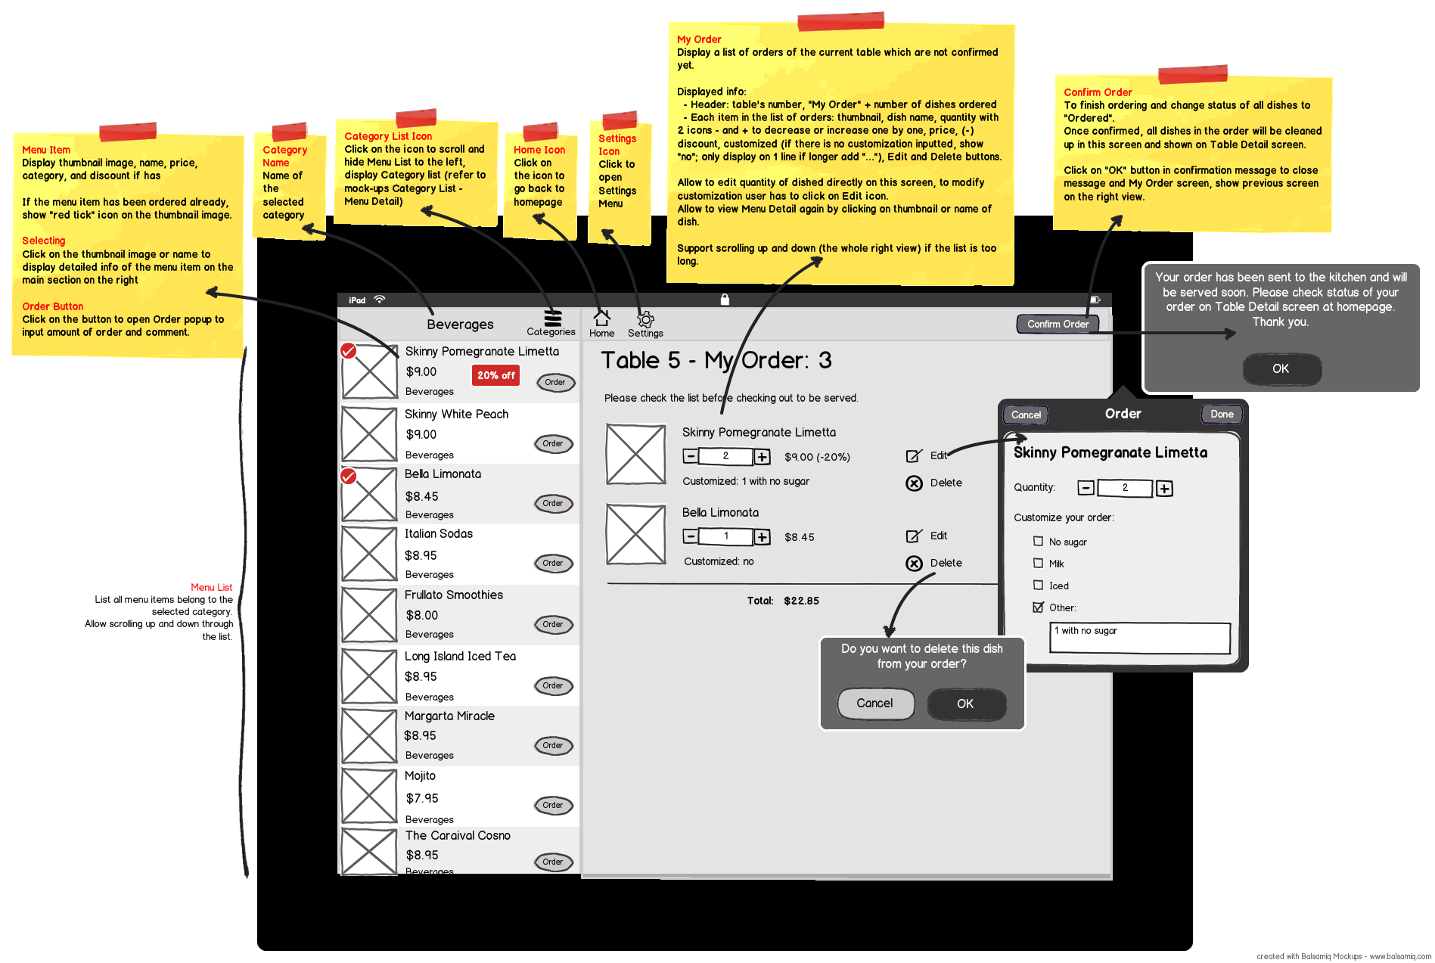
Refer to “Mockups/Images/Front-end/My Order.png”

Flow
- Users access their order list from My Order button in the detailed view of a menu item.
- The order list with all orders that are not confirmed yet is displayed to edit or delete.
- Users use Confirm Order button to submit their order to be prepared. The system will check if one of selected dishes run out of order or not, if “yes”, shows an alert message box to users reorder else shows a successful message box and then the order list will be removed from My Order screen and displayed on Table Detail screen, closes My Order screen and displays previous screen on the current view.

Business Rule
- My Order List:
  - Display a list of orders of the current table which are not confirmed yet.
  - Displayed info:
    - Header: table's number, "My Order" + number of dishes ordered
    - Each item in the list of orders: thumbnail, dish name, quantity with 2 icons - and + to decrease or increase one by one, price, (-) discount, customized (if there is no customization inputted, show "no"; only display on 1 line if longer add "..."), Edit and Delete buttons.
  - Allow to edit quantity of dished directly on this screen, to modify customization user has to click on Edit icon.
  - Allow to view Menu Detail again by clicking on thumbnail or name of dish.
  - Support scrolling up and down (the whole right view) if the list is too long.
  - Delete menu item - Confirmation message: “Do you want to delete this dish from your order?”
- Order Detail popover:
  - Load all predefined options for “Customize your order” of the selected menu item from database.
  - By default when adding a new order, no option is checked.
- Confirm Order Button:
  - To finish ordering and change status of all dishes to "Ordered".
  - Once confirmed, all dishes in the order will be cleaned up in this screen and shown on Table Detail screen.
  - Click on "OK" button in confirmation message to close message and My Order screen, show previous screen on the right view.
  - Confirm order – Reorder message: “This dish (es) <Names of dishes> is run out of orders, please select another dish (es).”
  - Confirm order - Confirmation message: “Your order has been sent to the kitchen and will be served soon. Please check status of your order on Table Detail screen at homepage. Thank you”

Customer Feedback

Screen
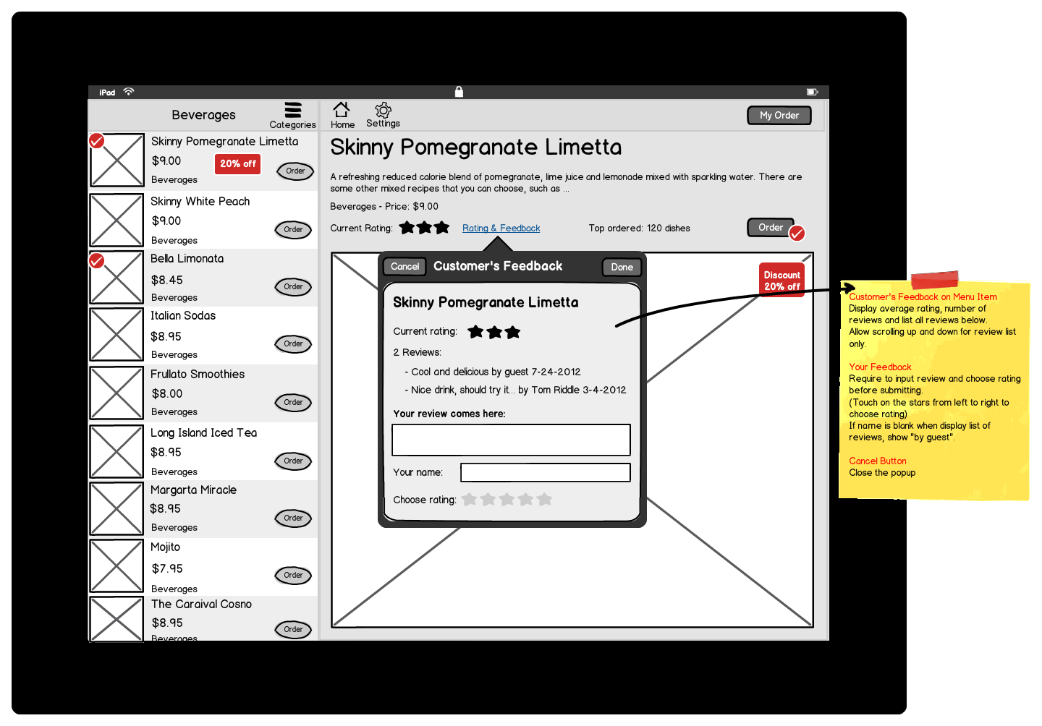
Refer to “Mockups/Images/Front-end/Customer Feedback Menu Item.png”

Flow
- User access Customer’s Feedback from Rating & Feedback link in detailed view of a menu item, Customer’s Feedback popover is shown.

Business Rule
- Display average rating, number of reviews and list all reviews that marked to be shown on the front-end by administrator in the back-end below.
- Allow scrolling up and down for review list only.
- Require to input review and choose rating before submitting.
- Touch on the stars from left to right to choose rating; do not allow choosing a half of star.
- If name is blank when display list of reviews, show "by guest".
- Current rating = total stars / number of feedbacks (using rounding up)
- A comment has just added will not be shown immediately on the front-end.
- Cancel button is to close the popover.

Table Detail

Screen
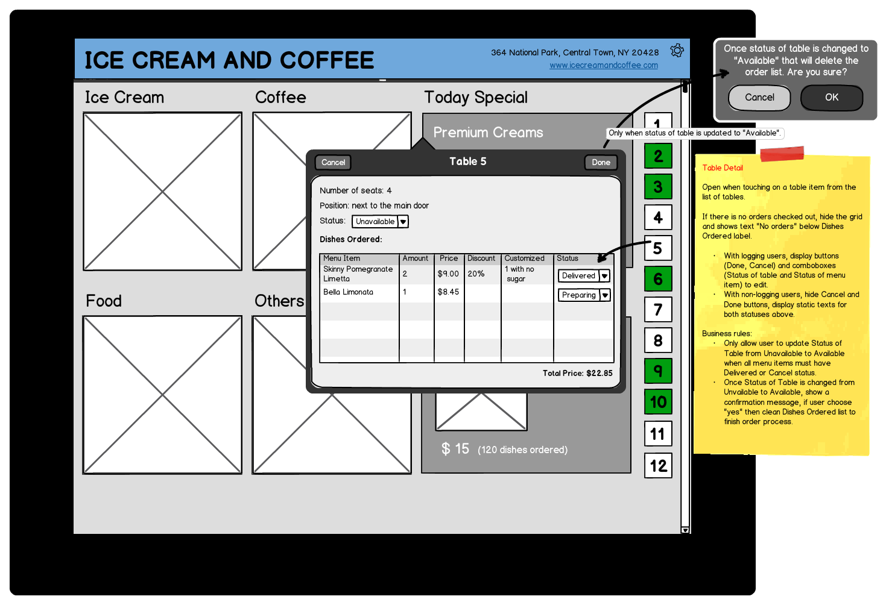
Refer to “Mockups/Images/Front-end/Table Detail.png”

Flow
- User access Table Detail from homepage by touching on each table’s number.
- Table Detail popover is shown.
- If users click “Done” after changing status of a table from “Unavailable” to “Available”, shows a confirmation message “Are you sure you want to close the current order of this table? This will remove all dishes from the list below. [Yes], [No]”. If yes, changes status of the table to “Available” and status of the order to “Closed”, all dishes of the order will not be displayed in Table Detail screen.

Business Rule
- If there is no orders checked out, hide the grid and show text "No orders" below Dishes Ordered label.
- Authorization:
  - With logging users, display buttons (Done, Cancel) and combo-boxes (Status of table and Status of menu item) to edit.
  - With non-logging users, hide Done button, display static texts for both statuses above.
- Status of a table is only changed from “Unavailable” to “Available” if meets the conditions below:
  - Status of all dished in the order must be “Delivered” or “Cancelled”.
  - Only logged-in users can change status.
Else show this message “Please check status of all dishes in the list before closing the order. [OK]”
- Once Status of Table is changed from Unavailable to Available, show a confirmation message “Once status of table is changed to "Available" that will delete the order list. Are you sure?”, if users choose "yes" then clean Dishes Ordered list to finish order process.
- Status of table: Available and Unavailable
- Status of menu item: Ordered, In-queue, Preparing, Delivered, and Cancelled.
- Status of order: In Progress and Closed.

Settings

Screen
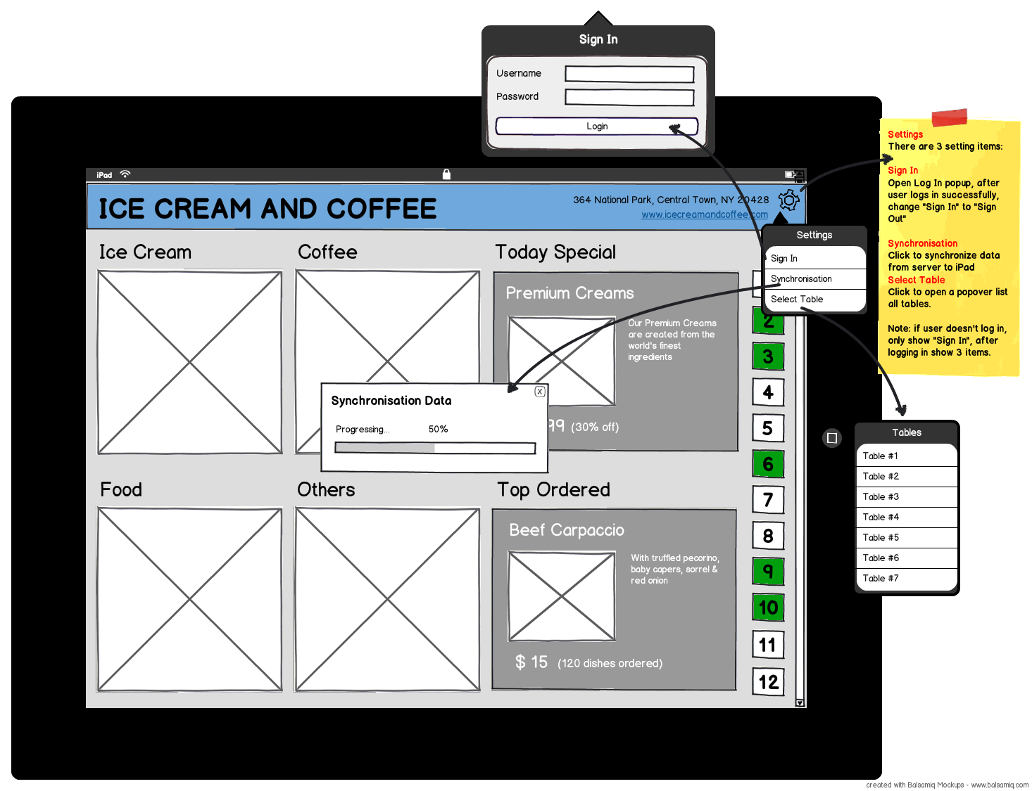
Refer to “Mockups/Images/Front-end/Settings.png”

Flow
- User access Settings menu from homepage.
- Select “Sign In” to open Sign In popover to log in the application to perform specific tasks. After logging in, closes “Sign In” popover and changes “Sign In” option in the Settings to “Sign Out”.
- Select “Synchronization” or “Select Table” to open Synchronization Data or Tables popover to synchronize data and select a table, closes the popover after finish.

Business Rule
- There are 3 setting items:
  - Sign In.
  - Synchronization: synchronize data from server to iPad.
  - Select Table: open a popover lists all tables, by default there is always a table selected and highlighted in another color (ex: yellow…)
- If user doesn't log in, only show "Sign In", after logging in show 3 items on the Setting menu.

BACK END

Login

Screen
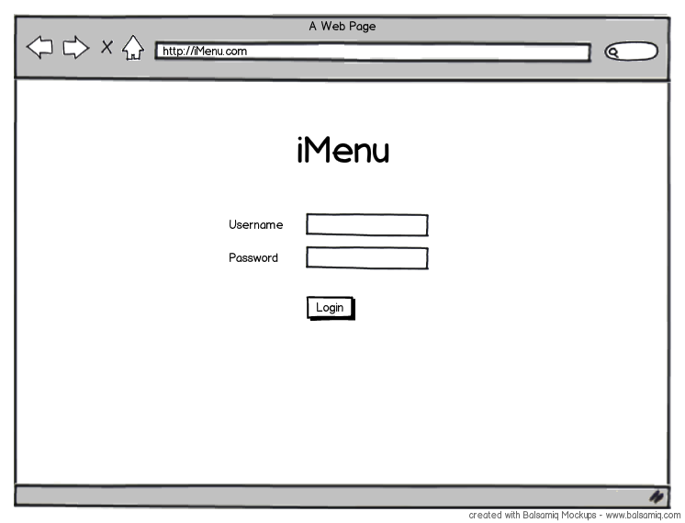
Refer to “Mockups/Images/Back-end/BO - Login.png”

Flow
- User access back-end site of iMenu from a link, for example, http://iMenu.com.
- Login screen is displayed.
- User inputs username and password to login, if not match displays an error message “Invalid username or password” else redirects to Category List screen. (see below)

Business Rule
- Only user with role is “Manager” can access back-end site of iMenu.

Category Management

Screen
Category List
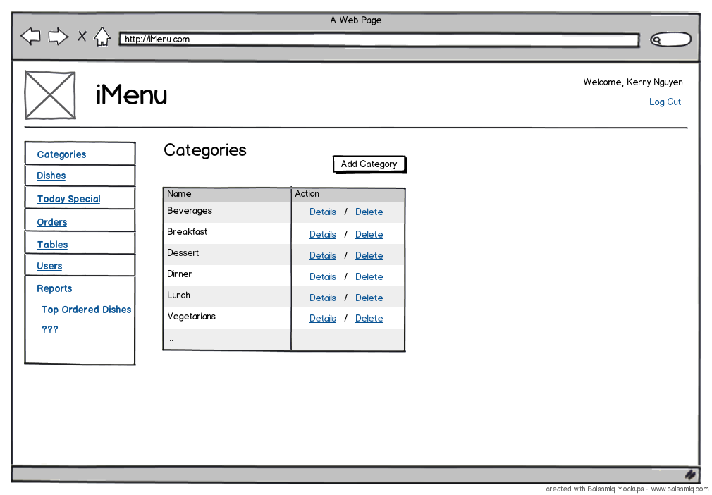
Refer to “Mockups/Images/Back-end/BO – Category List.png”

Category Detail
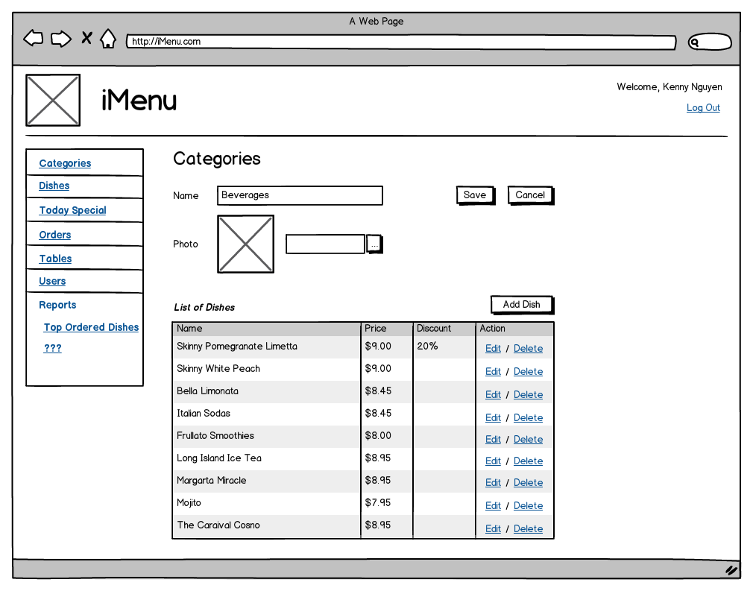
Refer to “Mockups/Images/Back-end/BO – Category Detail.png”

Flow
Category List
- After logging in user will see Category List screen by default page or access Category List from the link on left navigation – “Categories”.
- Clicks on “Details” link to view Category Detail screen of the select Category. User is able to edit Category Name then save it.
- Clicks on “Add Category” button to open Category Detail with Name textbox only to input Category Name and save.
- Clicks on “Delete” link to show a confirmation message box “Once deleted, all dishes and orders related to this category will not be shown. Are you sure you want to delete this category?” If “yes”, marks the selected category to “deleted”.
Category Detail
- Clicks on “Add Dish” to open “Add Dish” screen with the selected category is filled in Category combo-box. Refer to Flow section of Add Dish screen in Dish Management section below.
- Clicks on “Edit” link to open “Edit Dish” screen. Refer to Flow section of Edit Dish screen in Dish Management section below.
- Clicks on “Delete” link to mark delete selected dish. Refer to Flow section of Delete Dish screen in Dish Management section below.

Business Rule
- There is no category created, displays “No category” in the grid of Category List screen.
- If a category has no dish, displays “No dish” in the “List of Dishes” grid in Category Detail screen.
- Using paging, display 20 items per a page.

Dish Management

Screen
Dish List
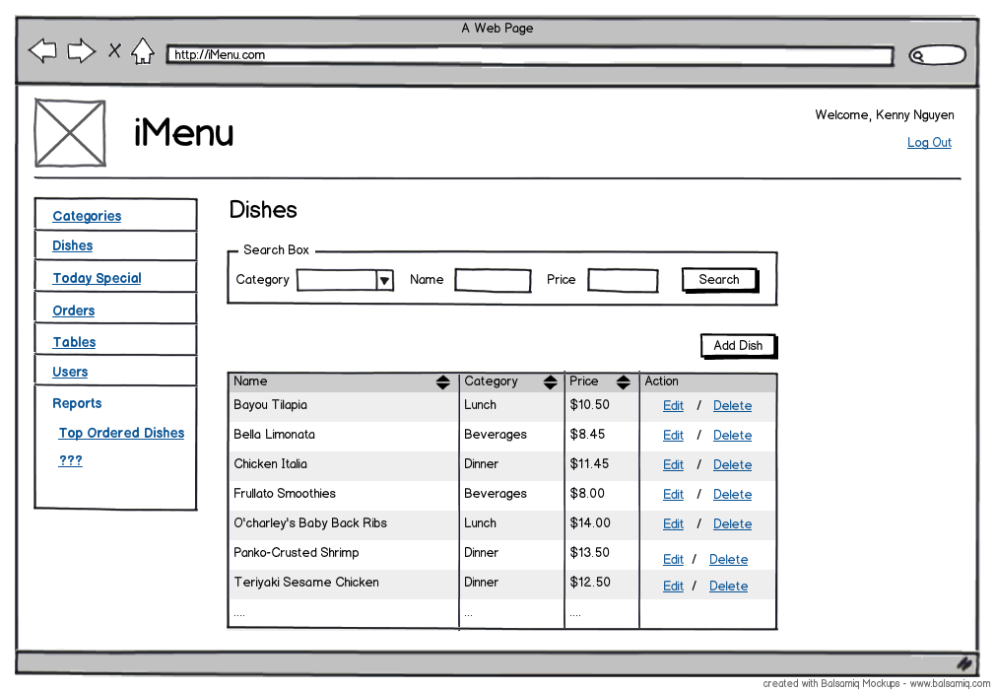
Refer to “Mockups/Images/Back-end/BO – Dish List.png”

Add Dish
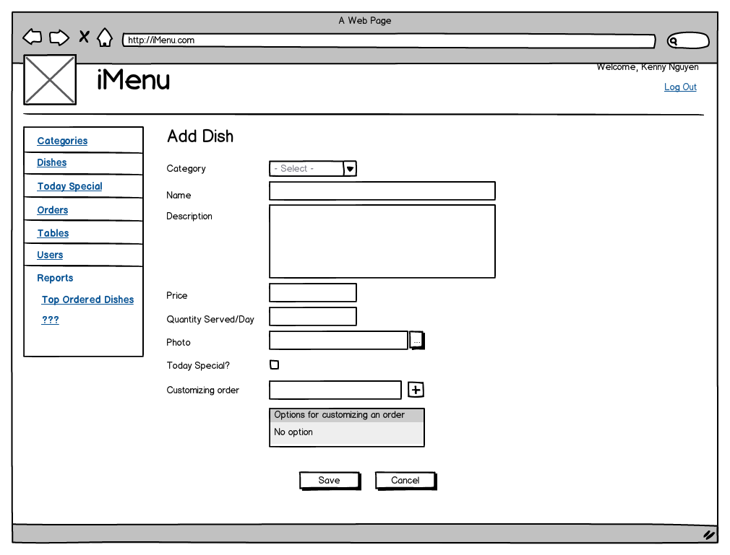
Refer to “Mockups/Images/Back-end/BO – Add Dish.png”

Edit Dish
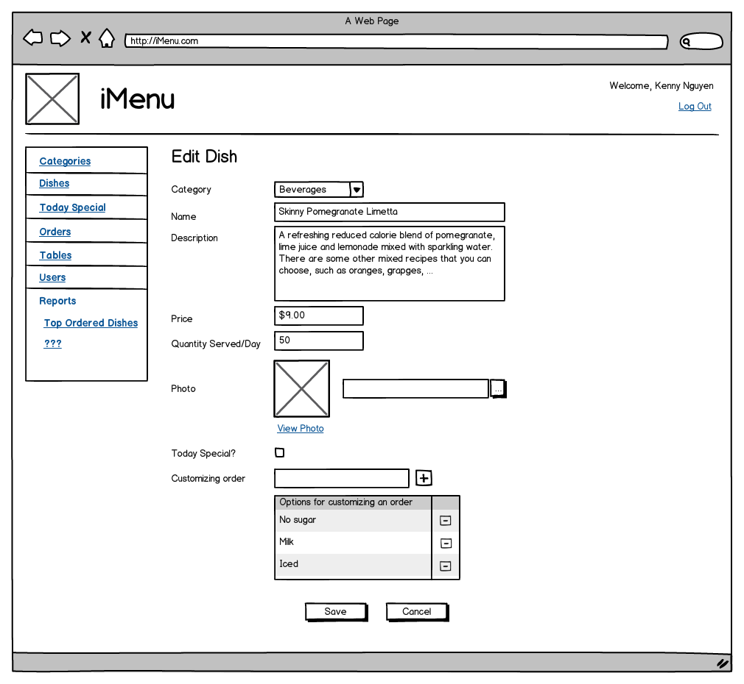
Refer to “Mockups/Images/Back-end/BO – Edit Dish.png”

Flow
Dish List
- User access Dish List from the link on left navigation – “Dishes”, Dishes screen is displayed with all dishes by default.
- For searching, inputs keywords into 3 fields then clicks on Search button to filter dishes and result is displayed on the list below.
- Clicks on “Add Dish” button to open Add Dish screen, see the flow below.
- Clicks on “Edit” link to open Edit Dish screen, see the flow below.
- Clicks on “Delete” link to show a confirmation message box “Are you sure you want to delete this dish?”, if yes, marks the selected dish to deleted.
Add Dish
- User inputs required fields on Add Dish screen then clicks on “Save” button to create a new dish and return the screen that called “Add Dish” screen.
- Clicks on “Cancel” button to go back the screen that called “Add Dish” screen.
- Customizing order: input customized option in the textbox then clicks on [+] icon to add the option into the list below but not saved yet. And clicks on [-] icon of each option to remove it from list of customized options of the current dish.
- Checks on “Today Special” checkbox to show this dish in Today Special category.
Edit Dish
- User edit data on the screen then clicks on “Save” button to store data and return the screen that called “Edit Dish” screen.
- Clicks on “Cancel” button to go back the screen that called “Edit Dish” screen.

Business Rule
- List all dishes when loading this page at first, sorted by name.
- Add/Edit Dish – Required fields: Category, Name, Description, and Price.
- Using paging, display 20 items per a page.

Today Special Management

Screen
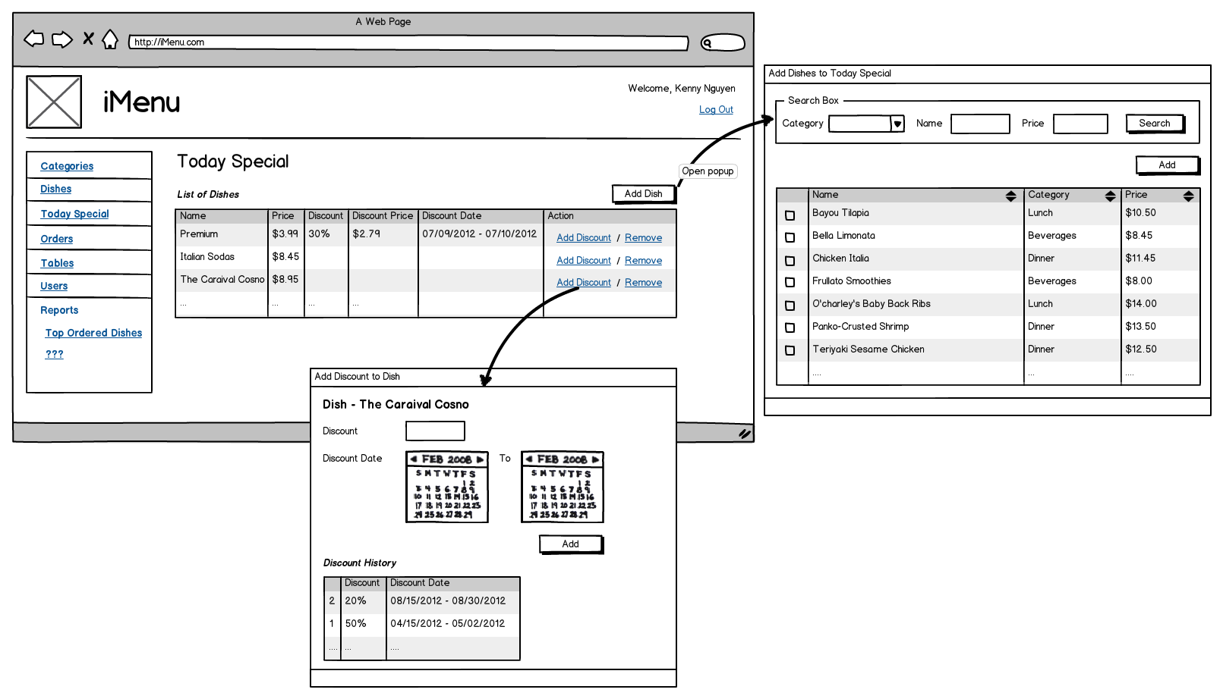
Refer to “Mockups/Images/Back-end/BO – Today Special.png”

Flow
- User access Today Special List from the link on left navigation – “Today Special”, Today Special screen is displayed with all dished added to this category.
- Clicks on “Add Discount” link to open “Add Discount to Dish” popup to add discount for the selected dish. User is able to input new discount or selects the Discount History to display selected item on fields then adjust.
- Clicks on “Remove” link to remove the selected dish from Today Special category.
- Clicks on Add Dish button to open “Add Dishes to Today Special” popup. User is able to search and select dishes then clicks on “Add” button to add them to Today Special category.

Business Rule
- For searching dishes to add to Today Special category – “Add Dishes to Today Special” popup – only search and display dishes which are not existent in Today Special category.
- Get the latest discount which is still in effective dates of a dish to display on the list of dishes on Today Special screen.
- “Add Discount” popup – when opens leave all fields empty, not allow adjusting discounts in the past from the Discount History grid.
- Using paging, display 20 items per a page.

Order Management

Screen
Order List
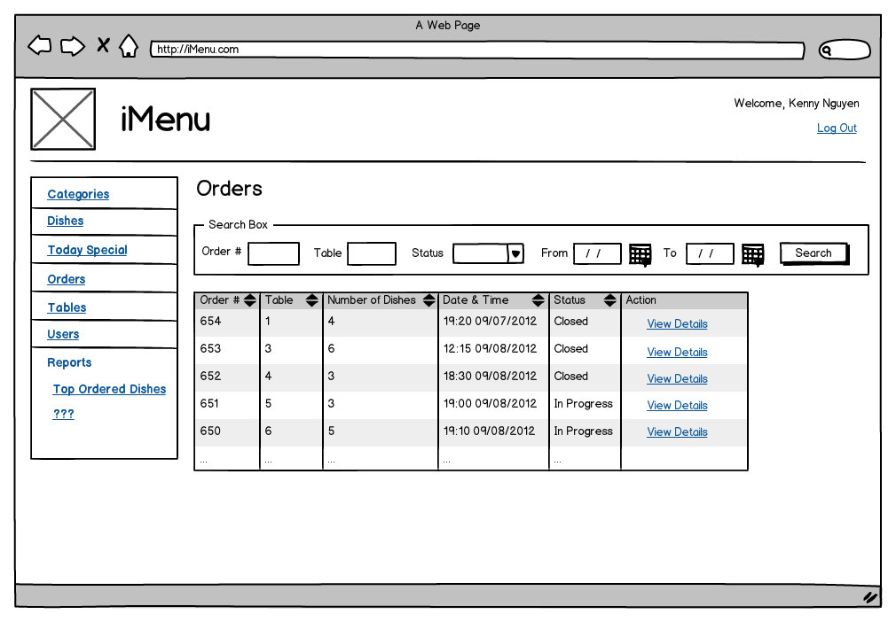
Refer to “Mockups/Images/Back-end/BO – Order List.png”

Order Detail
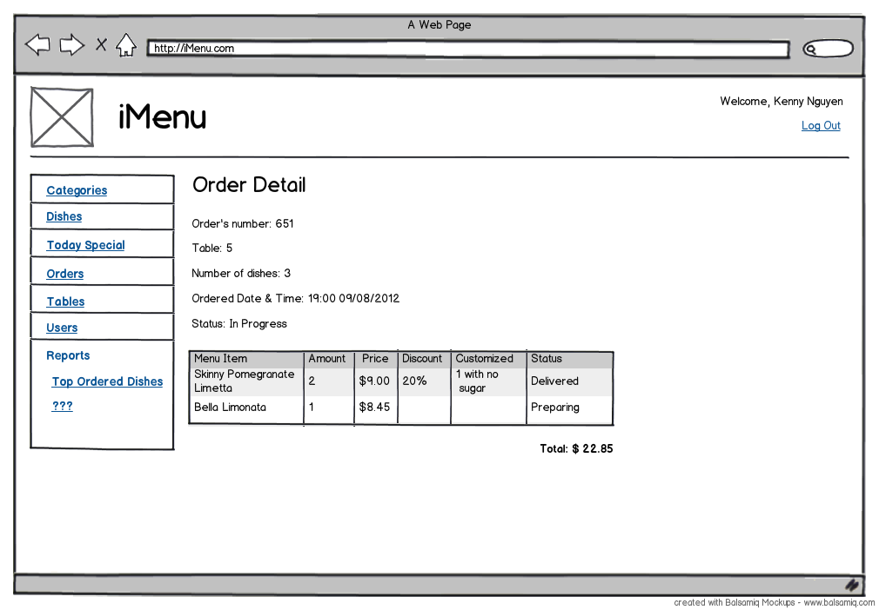
Refer to “Mockups/Images/Back-end/BO – Order Detail.png”

Flow
- Users access Order List from the link on left navigation – “Orders”, Orders screen is displayed with all orders.
- Users are able to search orders via Search Box then results are displayed on the list below.
- Clicks on “View Details” link to view Order Detail screen.

Business Rule
- List of orders is sorted by Date & Time ordered descending.
- All information in Orders and Order Details screen is for view only.
- Using paging, display 20 items per a page.

Table Management

Screen
Table List
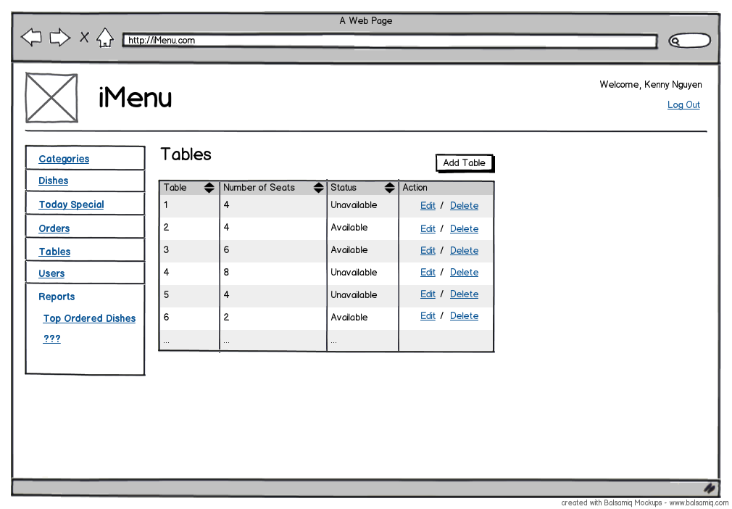
Refer to “Mockups/Images/Back-end/BO – Table List.png”

Table Detail
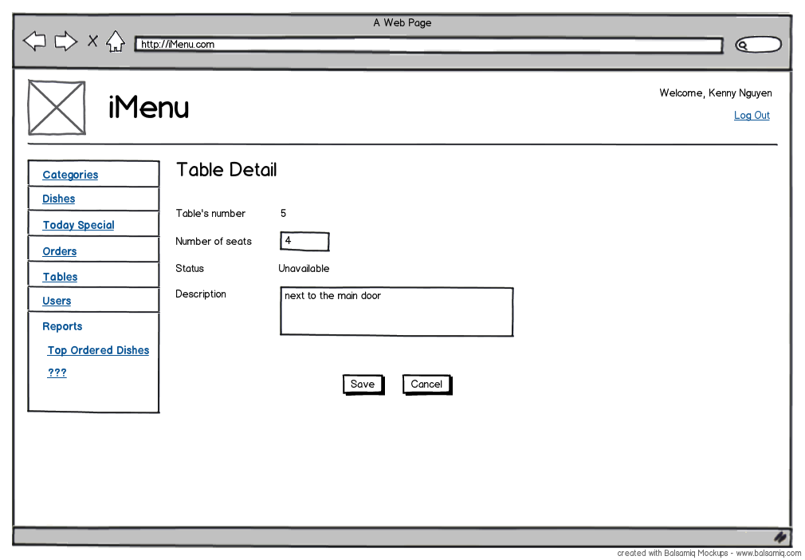
Refer to “Mockups/Images/Back-end/BO – Table Detail.png”

Flow
- User access Table List from the link on left navigation – “Tables”, Tables screen is displayed with all tables.
- Clicks on “Edit” link to move to Table Details screen. User is able to edit Number of seats or Description of selected table then clicks “Save” button to save changes and go back Tables screen.
- Clicks on “Add Table” button to move to Table Details screen with all fields available except for Status field which is set to “Available” by default. User inputs data then clicks “Save” button to create a new table and go back to Tables screen.
- Clicks on “Delete” link to show a confirmation message box “Are you sure you want to delete this table?”, if “yes”, marks the selected table to “deleted”.

Business Rule
- Only display tables that are not marked “deleted”.
- Add Table: table’s number is unique and required.
- Using paging, display 20 items per a page.

Customer Feedback Management

Screen
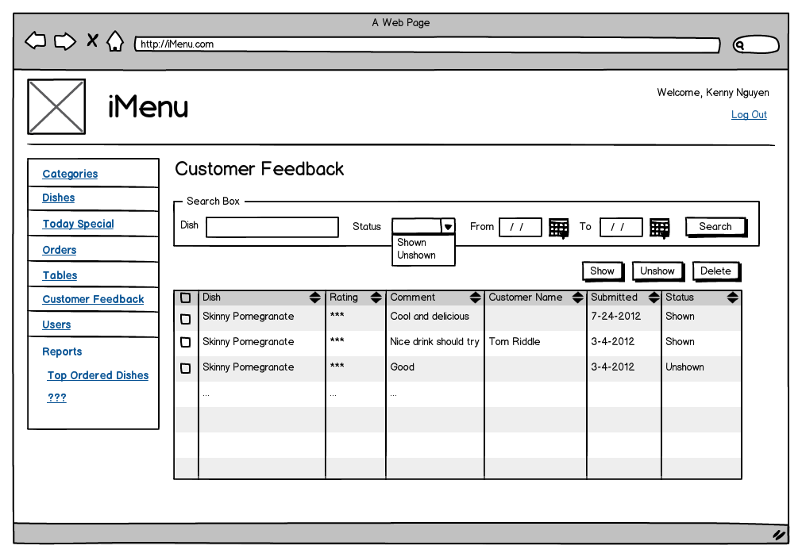
Refer to “Mockups/Images/Back-end/BO – Customer Feedback.png”

Flow
- Users access Customer Feedback from the link on left navigation – “Customer Feedback”, Customer Feedback screen is displayed.
- Users are able to search for feedback via Search Box then results are displayed on the list below and are selected to show or not on front-end by checking check-boxes and clicking on Show or Un-show button.
- Users can delete feedback using Delete button to remove all checked items from database.

Business Rule
- By default, only display feedbacks that are un-shown on the front-end on the list.

User Management

Screen
User List
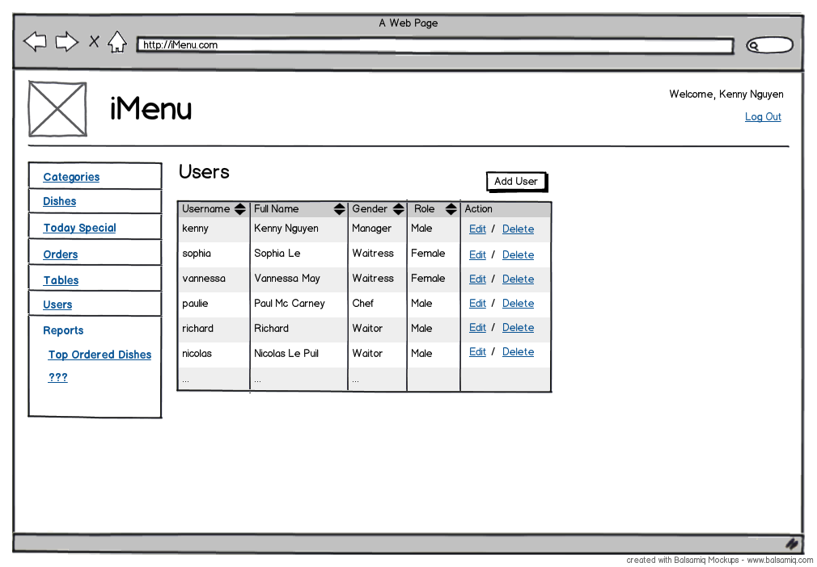
Refer to “Mockups/Images/Back-end/BO – User List.png”

User Detail
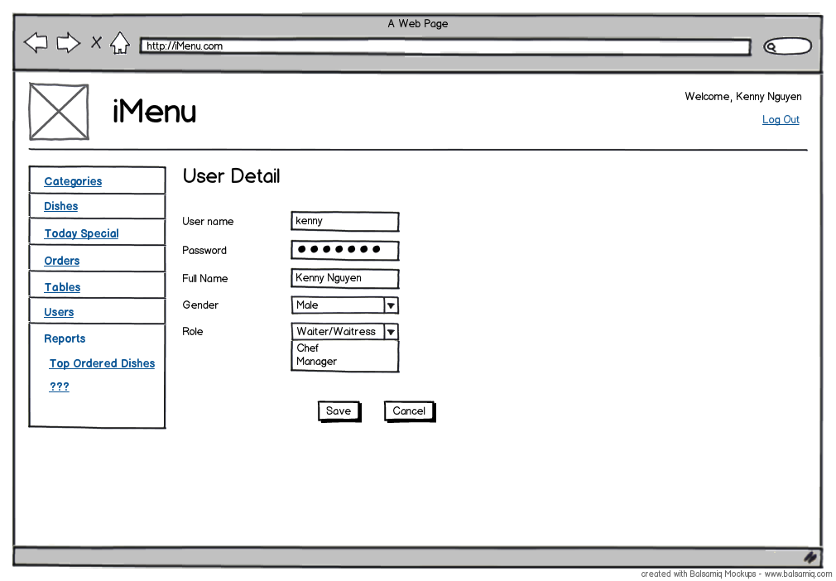
Refer to “Mockups/Images/Back-end/BO – User Detail.png”

Flow
- User access User List from the link on left navigation – “Users”, Users screen is displayed.
- Clicks on “Edit” link or “Add User” button to move to User Detail screen. User is able to edit or input new data then clicks on “Save” button to update/create user and go back to Users screen.
- Clicks on “Delete” link to show a confirmation message box “Are you sure you want to delete this user?”, if “yes”, marks the selected user to “deleted”.

Business Rule
- Required fields: user name, password, full name, gender, and role.
- Using paging, display 20 items per a page.

Reports

Screen

Top Ordered Dishes
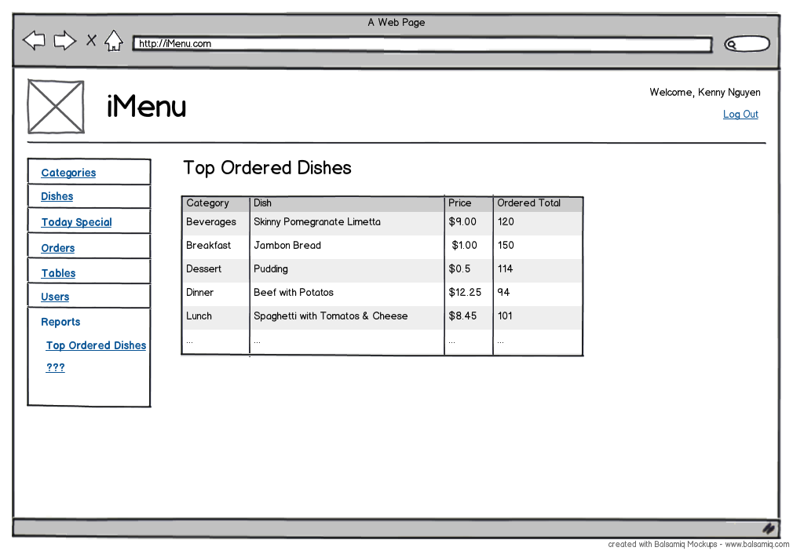
Refer to “Mockups/Images/Back-end/BO – Top Ordered Dishes.png”

Sales Report by Category
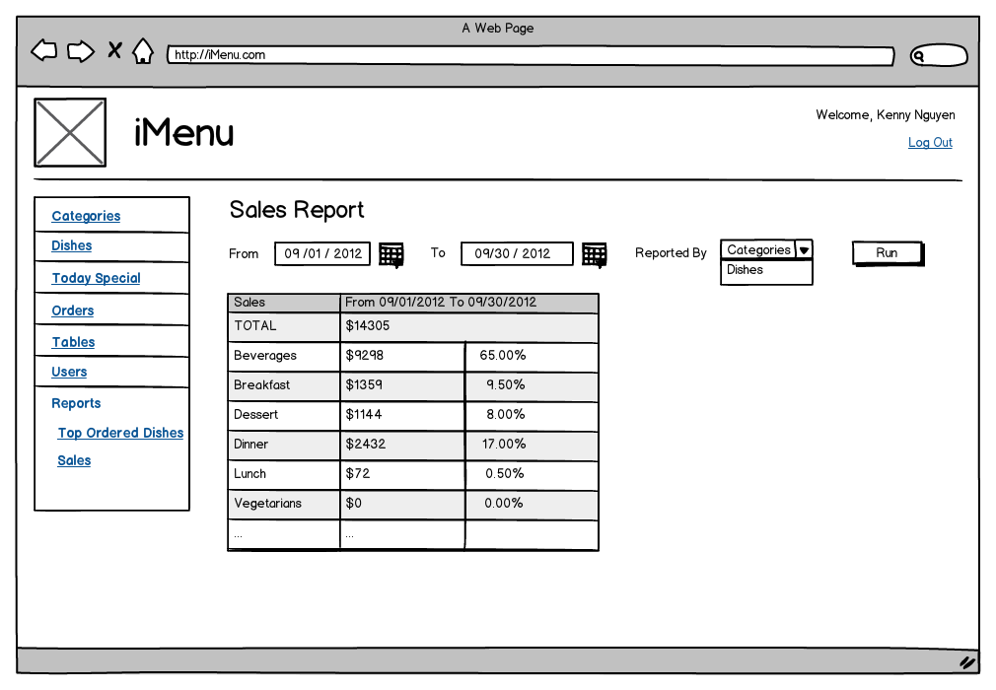
Refer to “Mockups/Images/Back-end/BO – Sales Report - Category.png”

Sales Report by Dish
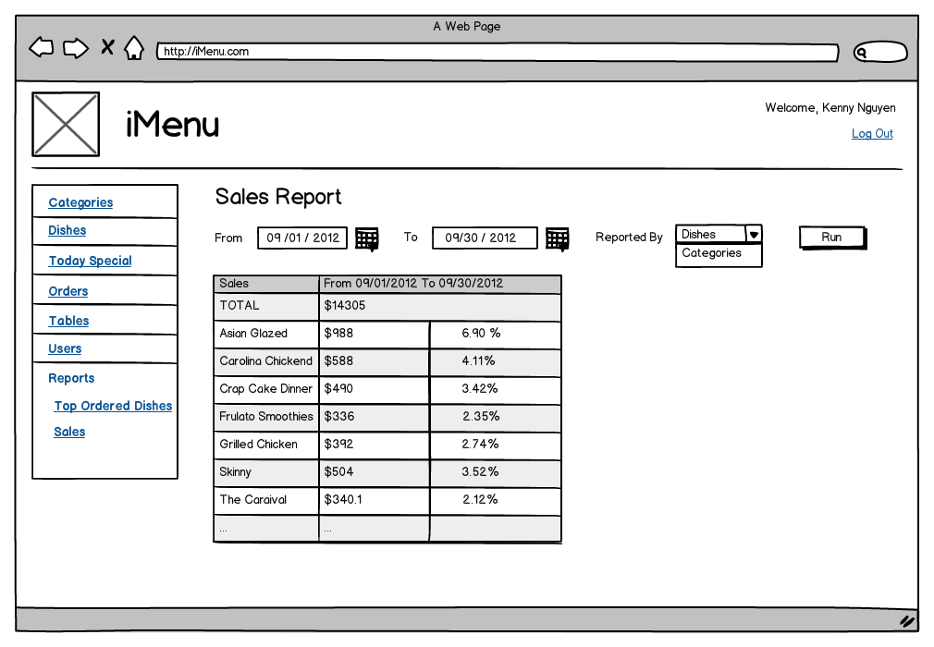
Refer to “Mockups/Images/Back-end/BO – Sales Report - Dish.png”

Flow
- User access Top Ordered Dishes report from the link on left navigation – “Top Ordered Dishes” in Reports section, Top Ordered Dishes screen is displayed.
- User access Sales Report from the link on left navigation – “Sales” in Reports section, Sales Report screen is displayed to select a period of time for the report then clicks on Run button to display report result.

Business Rule
- Top Ordered Dishes: list of dishes that are got from each category in which that dish has been ordered the most within 7 days.
- Sales Report: calculate total revenue of all dishes of each category or each dish in the selected period of time. By default category is selected for “Reported By combo-box.

